L4-W5-DBS301-Group functions

*STEP 1: Put the SQL and the results after each question below*

*STEP 2: Submit on Blackboard.*

1 Display the difference between the Average pay and Lowest pay in the company.

Name this result *Real Amount*.

**select (avg(salary) - min(salary)) "Real Amount"**

**from employees;**

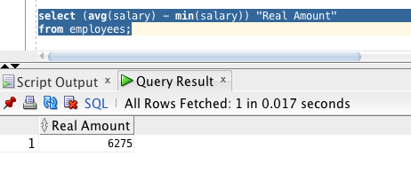

2 Display the department number and Highest, Lowest and Average pay per each department. Name these results *High, Low* and *Avg.*

Sort the output so that the department with highest average salary is shown first.

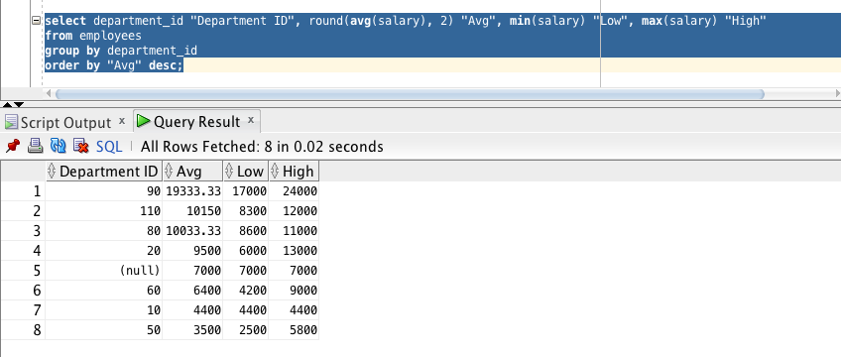

3 Display how many people work the same job in the same department.

Name these results *Dept#, Job* and *How Many.*

Include only jobs that involve more than one person.

Sort the output so that jobs with the most people involved are shown first.

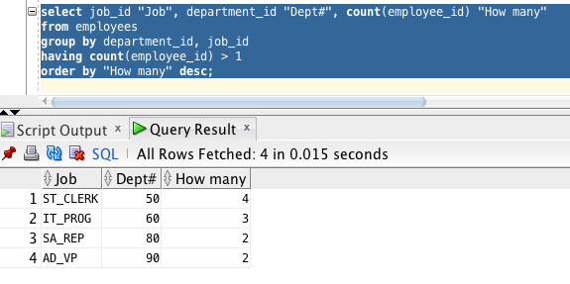

4 For each job title display the job title and total amount paid each month for this type of the job. Exclude titles *AD_PRES* and *AD_VP* and also include only jobs that require more than $15,000.

Sort the output so that top paid jobs are shown first.

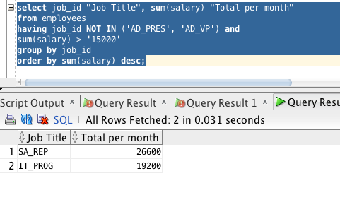

5 For each manager number display how many persons he / she supervises. Exclude managers with numbers 100, 101 and 102 and also include only those managers that supervise more than 2 persons.

Sort the output so that manager numbers with the most supervised persons are shown first.

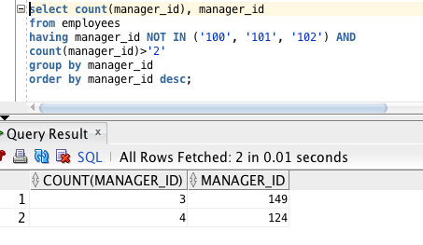

6 For each department show the latest and earliest hire date, BUT

- exclude departments 10 and 20

- also exclude those departments where the last person was hired in this century.

- Sort the output so that the most recent, meaning latest hire dates, are shown first.

